Free Youtube views for an unlimited number of your videos! Boost your video's popularity using their simple and free method! Or, buy Youtube views and other services here.

[ythunder.com](https://ythunder.com/) has free & open registrations.

Sub4Sub, or ‘Subscribers for Subscribers,’ is being touted by some as the safest way to grow your audience, not just on [YouTube](https://ythunder.com/) but on other social media sites as well.

It’s easy to see how you can grow your following using a sub4sub tactic and why people would want to try it. Is it really Free Youtube views：[ythunder.com](https://ythunder.com/)

a good idea, though? Is it an effective (and safe) way to grow your channel?

Check out the advantages and disadvantages we’ve compiled below and decide for yourself if sub4sub is truly as great as people purport it to be.Free Youtube views：[ythunder.com](https://ythunder.com/)



What is Sub4Sub?

For those who have never heard of the concept of sub4sub before, the simplest explanation for it would be **“I subscribe to you, you subscribe to me.”** This is often achieved by people asking directly in the comments section, looking for anyone interested in a sub4sub deal.

Apps and websites providing this service have also mushroomed to serve as platforms for those who are willing to subscribe to any channel as long as they get a subscribe back. There is no other requirement or fee to pay. You simply have to subscribe and you’ll be subscribed to in return.

Why it’s Not So Great

Technically, sub4sub works and it’s a reliable way to inflate your Subscriber count on [YouTube](https://ythunder.com/). There are just a few problematic points that make it a complete waste of your time. Here they are.

**Your views stay low**



The people who subscribed to you are not required or incentivized to watch your videos. **As a result, you get more Subscribers but you don‘t usually get a corresponding increase in views on your videos.** Some might make some effort to watch, in the hope that you will watch their videos too, but most won’t. These people aren’t naturally interested in your videos, so they will most likely not finish them if they happen to click one. You don‘t get any audience retention points for that.

Also, you have to imagine that a typical member of a sub4sub service is subscribing to a ton of channels. You don’t expect them to go through and watch videos from all those channels, do you?

**This is why buying** [**YouTube views**](https://ythunder.com/) **is one hundred times more effective than using a sub4sub service. When you buy high-retention** [**YouTube views**](https://ythunder.com/)**,** [**YouTube**](https://ythunder.com/) **notices and places more value on your video.**

Your bought [YouTube views](https://ythunder.com/) will also attract real views from other users, who will see your high view count and decide your video must be a good one. That’s the power of social proof!

**You’re unlikely to get any engagement**

Because the people who subscribed to you are also subscribed to 499 other people (at least), the chances of you getting comments and shares from them is very low.

If you don’t get views, as mentioned earlier, you don’t get comments. **The total engagement on your videos would be very little.**

**You don’t get a subscription guarantee**

The possibility of losing your subscribers is very real. It’s a common practice for those who use such tactics for social media growth to unsubscribe or unfollow once they’ve reached their target number of subscribers.

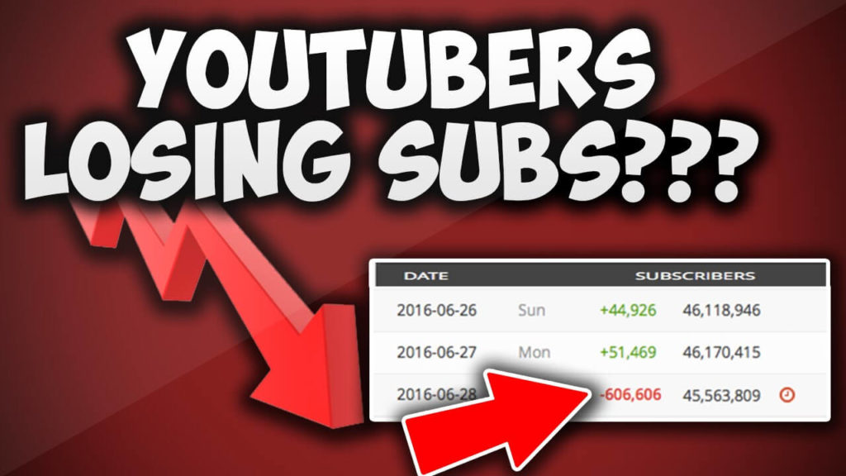

**Participating in a sub4sub does not guarantee you’ll retain the subscribers you’ll get for any significant length of time, even if you never unsubscribe from any of them!**

**It takes forever**

You often have to manually subscribe to every channel you want to subscribe to, although these services will often present them in a nice format to make it easy. But you’ll still only get one subscriber for every channel you subscribe to, which makes this a very tedious process that produces results very slowly.

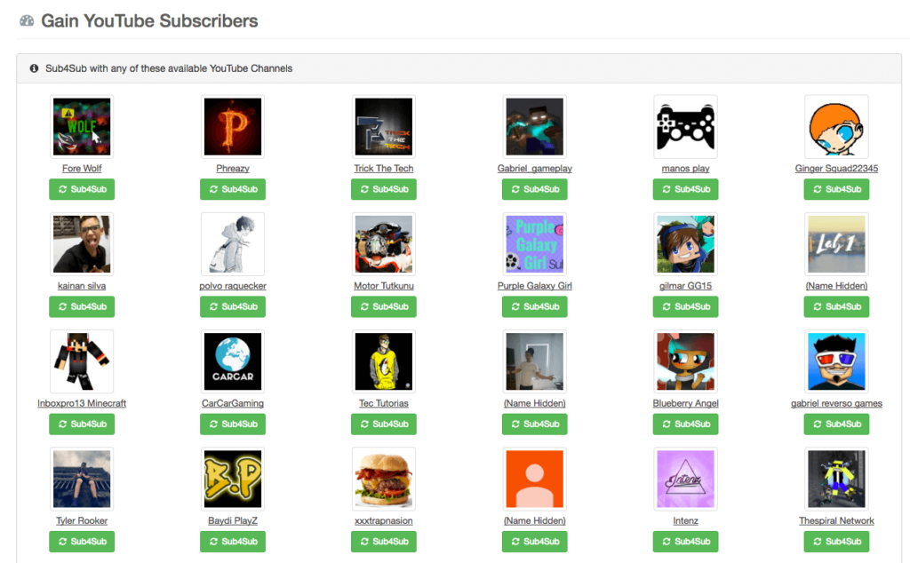

Image credit: ythunder.com

Why it Sounds Like a Good Idea

In theory, sub4sub is a good idea to spread the word about your channel while you’re getting subscribers. In practice, it is not an effective method of growing your channel. So, where does the appeal come from?

**You are able to get more subscribers**

In the world of marketing, having a high number of subscribers works in your favor. It tells people how important you are, and lends support to your credibility and authority online.

**However, because you don’t get any real engagement from these subscribers, instead of helping you establish your channel, it might actually hinder your** [**YouTube**](https://ythunder.com/) **growth.**

A high subscriber/low engagement ratio means your channel is not performing well and [YouTube](https://ythunder.com/) will certainly take notice. You can say goodbye to any chance of getting on first page results. **Channels with high subscriber counts but low engagement can also set off red flags for** [**YouTube**](https://ythunder.com/)**, and might get penalized for it.**



**Subscribers may turn into real ones**

If you happen to have the same interests or you are in the same niche as those people who are subscribed to you, they might turn into “real” subscribers. If you create cool content, then it *might* even be a foregone conclusion.

Still, this scenario is highly unlikely if you can’t get them to watch your videos – and most people in the sub4sub community are unlikely to do so. **Even if you are eager to help your fellow** [**YouTuber**](https://ythunder.com/)**s succeed on** [**YouTube**](https://ythunder.com/)**, most are just in it for the subscribers.**

What You Can Do to Grow Your Channel

Indeed, there are more disadvantages than there are advantages to using a sub4sub. Don’t despair, though, you can still grow your channel in a highly saturated [YouTube](https://ythunder.com/) market. Here are some of the proven ways to build your presence on the platform.

**Keep promoting your channel**

Never stop marketing your channel even if it’s just a simple sharing on your other social media channels. The surest way to stop growth is to stop the strategies that are increasing your subscribers.

So don’t get tired of sharing your content and reaching out to a wider audience. Having plenty of truly valuable content helps too, which brings us to another strategy you can use.



**Focus on content**

Content is still king, especially on [YouTube](https://ythunder.com/) where the algorithm is structured to reward videos that appeal to viewers based on their engagement activities. But there’s a lot of crap on [YouTube](https://ythunder.com/) that just wastes your time, as we all know.

So if you’re actually making great content that encourages engagement on your videos, you’ll stand out despite the noise. It takes more work, but what else would you expect?

**Choose better services**

Instead of wasting time clicking a sub4sub all day, [buy YouTube Views](https://ythunder.com/) instead. A view is a primary form of engagement and if your videos have high Views, [YouTube](https://ythunder.com/) will value them more.

**Bought** [**YouTube Views**](https://ythunder.com/) **can help you rank high on search results, which in turn gets you real Views.**



Getting real viewers is the first step to getting real subscribers. Bought [YouTube Views](https://ythunder.com/) won’t get your channel banned, either. There is a rumor that you’ll be penalized, but the reality is you won’t (at least in our experience) because that will incite users to buy views for their competitors in efforts to bring their competitors’ channels down. This is called negative SEO and you can be sure that Google does not want that.

In reality, the worst that can happen is that you’ll lose those views when [YouTube](https://ythunder.com/) determines they’re fake, although this has never happened to any of our test accounts. This is why it’s important to buy from reputable providers who only sell high-quality [YouTube Views](https://ythunder.com/).

Turn Your Viewers into Subscribers Today!

Sub4sub has some kind of potential, but it doesn’t seem like much. Overall it looks like a waste of time, which could potentially fill your subscriber base with uninterested and unengaged users – not a situation you want to be in.

If you want to grow your channel using bought services, [buy YouTube Views](https://ythunder.com/) instead. As with all things in this world there are no guarantees, but if you pair this strategy with a solid organic [YouTube](https://ythunder.com/) marketing campaign and videos that provide real value, you’re bound to get real traffic that will cement your channel’s success to some degree.

So, ditch the sub4sub method and stick with what really works!



Free Youtube views for an unlimited number of your videos! Boost your video's popularity using their simple and free method! Or, buy Youtube views and other services here.

[ythunder.com](https://ythunder.com/) has free & open registrations.